INTRODUCTION

1. INTRODUCTION TO THE UML

The unified modeling language (UML) is a standard language for writing software blueprints. The UML may be used to visualize, specify, construct and document the artifacts of software-intensive system. The UML was released in 1997 as a method to diagram software design. It was designed by a consortium of the best minds in object oriented analysis and design. It is by far the most exciting thing to happen to the software industry in recent years. Every other engineering discipline has a standard method of documentation. Electronic engineers have schematic diagrams, architects and mechanical engineers have blueprints and mechanical diagrams. The software industry now has UML.

AN OVERVIEW OF THE UML:--

The UML is a language for

- Visualizing
- Specifying
- Constructing
- Documenting

The UML is a language for Visualizing:--

For many programmers, the distance between thinking of an implementation and then pounding it out in code is close to zero. You think it, you code it. In fact, some things are best cast directly in code. Text is a wonderfully minimal and direct way to write expressions and algorithms.
In such cases the programmer is still doing some modeling. He or she may even sketch out a few ideas on a white board or on a napkin. However some problems are exists.

The UML is a language for Specifying:--

Specifying means building models that are precise, unambiguous and complete. In particular, the UML addresses the specification of all the important analysis, design and implementation decision that must be made in developing and deploying a software intensive system.

The UML is a language for Constructing:--

The UML is not a visual programming language, but its models can be directly connected to a variety of programming languages. This means it is possible to map a model in the UML, to a programming language such as java, c++, or visual basic or even to a table in a relational databases or the persistent store of an OO databases.

The UML is a Language for Documenting:--

Healthy software Organizations produces all sorts of artifacts in addition to raw executable code. These artifacts include

- Requirements
- Architecture
- Design
- Source code
- Project plans
- Tests
- Prototypes
- Releases

Consider some of the benefits of UML:--

  - Your s/w system is professionally designed and documented before it is coded. You will know exactly what you are getting an advance.

  - Since system design comes first, reusable code is easily spotted and coded with the highest efficiency. You will have lower development costs.

  - Logic ‘holes’ can be spotted in the design drawings. Your software will behave as you expect it to. There are fewer surprises.

  - The overall system design will dictate the way the s/w is developed. The right decisions are made before you are married to poorly written code. Again, your overall costs will be less.

  - UML lets us see the big picture. We can develop more memory and processor efficient systems.

  - When we come back to make modifications to your system, it is much easier to work on a system that has UML documentation. Much less ‘relearning ‘takes place. Your system maintenance costs will be lower.

  - If you should find the need to work with another developer, the UML diagrams will allow them to get up to speed quickly in your custom system. Think of it as a schematic to a radio. How could a tech fix it without it?

  - If we need to communicate with outside contractors or even your own programmers, it is much more efficient.

APPLICATIONS OF THE UML:--

The UML is intended primarily for software-intensive system. It has been used effectively for such domains as

- Enterprise information systems
- Banking and financial services.
- telecommunications
- Defense / aerospace
- Retail
- Medical electronics
- Scientific
- Distributed web-based services

A conceptual model of the UML:--

To understand UML, you need to form a conceptual model of the languages, and this request learning there major elements, the uml’s basic building blocks, the rules that dictate how those building blocks may be put together, and some common mechanisms that apply throughout the UML.

Building blocks of the UML:--

The vocabulary of the UML encompasses three kinds of building blocks:

- THINGS
- RELATIONSHIPS
- DIAGRAMS

Things are the abstractions that are first class citizen in a model; relationships tie these things together; diagrams group interesting collection of the things.

Things in UML:--

There are four kinds of things in UML

- Structural things
- Behavior things
- Grouping things
- Annotational things

These things are basic building blocks of the UML.

Structural things: Structural things are the nouns of UML models. These are the mostly static parts of a model, representing elements that are either conceptual or physical. In all, there are seven kinds of structural things.

First, a Class is a description of a set of objects that share the same attributes, operations, relationships and semantics. A class implements one or more interfaces. Graphically a class is rendered as a rectangle, usually including its name, attributes , and operations.

Second and Interface is a collection of operations that specify a service of a class or component. An interface there fore describes the externally visible behavior of that element. An Interface defines a set of operations specifications but never a set of operation implementations.

Third, Collaboration defines an interaction and is a society of roles and other element that work together to provides some cooperative behavior that’s bigger than the sum of all the element. Therefore, collaboration have structural, as well as behavioral, dimensions. A given class might participate in several collaborations.

Fourth, a use case is a description of set of sequence of actions that a system performs that yields an observable result of value to particular. A use case is used to structure the behavioral things in a model, a use case is a realized by a collaboration.

Fifth, an Active class is a class whose objects own one or more processes or threads and therefore can initiate control activity. An active class just like a class expects that its objects represent elements whose behavior is concurrent with other elements.

Sixth, a Component is a physical and replaceable part of a system that conforms to and provides the realization of a set of interfaces component typically represent the physical packaging of otherwise logical elements, such as classes, interfaces, and collaborations.

Seventh, a node is a physical element that exists at runtime and represents a computational resources generally having at least some memory and often, processing capability. A set of components may residue on a node and may also migrate from node to node.

Behavioral things: Behavioral things are dynamic part of UML model. These are the verbs of a model, representing behavior overtime and space. In all, there are two primary kinds of behavioral things.

First, an Interaction is a behavioral that comprises a set of messages exchanged among a set of objects within a particular context to accomplish a specific purpose the behavior of a society of objects or of an individual operation may be specified with an interaction. An interaction involves a number of other elements, including messages, action sequences.

Second, a State Machine is a behavior specifies the sequences of states an object or an interaction goes through during its lifetime in response to events, together, with its responses those events. The behavior of an individual class or a collaboration of classes ay be specified with a state machine. A state machine involves a number of the elements, including states, transitions, event, and activities.

Grouping Things : Grouping Things are organizational parts of the UML models. These are the boxes into which a model can be decomposed. In all, there is one primary kind of grouping things, namely , packages.

A package is a general-purpose mechanism for organizing elements in to group. Structural Things, Behavioral things, and even other grouping things may be placed in a package. Unlike package is purely conceptual. Packages are the basic grouping things with which you may organize a UML model. There are variations. Such as frame works, models, and subsystems.

Annotational Things: Annotational things are explanatory parts of the UML models. These are the comments you may apply to describe illuminate, and remark about any elements in a model. There is one primary kind of annotational thing, called a node. A note is a simply a symbol for rendering constraints and comments attached to and element or a collection of elements.

UML Diagram set pf Symbols:

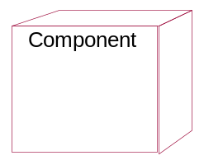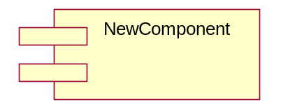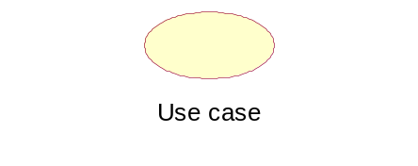
Interface
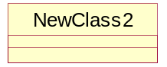
Association
Generalization

Dependency
Realization

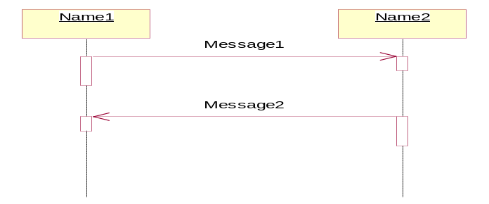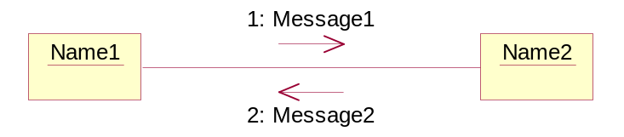

Activity

<<Stereotype>>
{Constraints}
{Tagged Values}

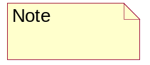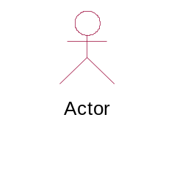

Relationships

A relationship is a connection among things. In object-Oriented modeling the three most important relationships are dependencies, generalization and associations. Simply it is a path, with different kinds of lines use to distinguish the kinds of relationships.

Dependency:

A dependency is a using-relationship that states that a change if specification of one thing, but not necessarily the reverse. Graphically, a dependency is rendered as a dashed directed line directed to the thing being depended on. Use dependencies when you want to show one thing using another. We use dependencies in the context of classes to show that one class uses another class as an argument in the signature of an operation. This is very much a using relationship. If the used classed changes, the operation of the other class may be affected, as well, because the used class may now present a different interface or behavior. In the UML you can also create dependences among many other things, especially notes and packages.

Generalization:

A generalization is a relationship between a general thing and a more specific kind of that thing generalization is sometimes called and “is-a-kind-of” relationship. One thing is-a-kind-of a more general thing. Generalization means that objects of the child May be used anywhere the parent may appear, but not he reverse. In other words, generalization means that the child is substitutable for the parent. A child inherits the properties of its parents, especially their, attributes and operations. An operation of a child that has the same signature as an operation in a parent overrides the operation of the parent, use generalizations when you want to show parent/child relationships.

Multiplicity:

An association represents a structural relationship among objects. In many modeling situations, its important for you to state how many objects may be connected across an instance of an association. This ”how many “ is called the multiplicity of an association’s role, and is written as an expression that evaluates to range of values or an explicit for each object of the class at the opposite end, there must be that many objects at the near end. You can shw a multiplicity of exactly one, zero, or one, many, or one or more. You can even state an exact number.

Aggregation :

A plain association between two classes represents a structural relationship between peers, meaning that both classes are conceptually at the same level, no one more important that the other. Sometimes, you will want to model a whole “whole/part” relationship, in which one class represents a larger thing. Which consist of smaller things? This kind of relationships, meaning that an object of the whole has objects of the part. Aggregation is really just a special kind of association and is specified by adorning a plain association with an open diamond at the whole end.

Diagrams in the UML:

The UML certain number of graphical elements combined into diagrams. Because it is a language, the UML has rules for combining these elements. The purpose of the diagrams is present multiple views of a system, and this set of multiple views is called a model.

A diagram is the graphical representation of a set of the elements, most often rendered as a connection graph of vertices and arcs, you draw diagrams to visualize a system from different trivial systems, a diagram represents an elided view of the elements that make grams or in no diagrams at all. The UML includes nine types of diagrams.

- Class Diagram
- Object Diagram
- Use case Diagram
- Sequence Diagram
- Collaboration Diagram
- State chart Diagram
- Activity Diagram
- Component Diagram
- Deployment Diagram

Let’s take a fall into categories (computers, automobiles, trees….). We refer to these categories as classes. A class is a category or group of things that have similar attributes and common behaviors. Class diagram provides the representations used by the developers.

The graphical representation of the class is as follows:

Class Name
Attribute1:type
Attribute2:type
Attribute3:type=”default values”
……..

Operation1()
Operation2(list of parameters)
Operation3():return type

Object diagram:

An object is an instance of class-specific things that has specific values of the attributes and behavior.

A Use Case Diagram:

A use case is a description of a system’s behavior from a user’s standpoint.
For system developers, this is a valuable tool: it’s a tried-and-true technique for gathering system requirements from a user’s point of view. That’s important if the goal is to build a system that real people can use. In graphical representations of use cases a symbol for the actor is used.
The actor is the entity that initiates the use case. It can be a person or another system.

The representation of the use case diagram is as follows:

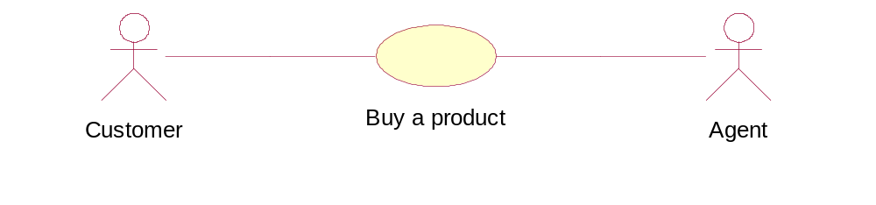
State Diagram:

At any given time, an object is in particular state. State diagrams represent these states and their changes during time. Every state diagram starts with symbol that represents start state, and ends with symbol for the end state. For example every person can be a newborn, infant, teenager or adult.

The representation of the state diagram as follows:

The UML symbols in a state diagram. The top area stands for the state’s name, middle area is for state variables, and the bottom is for activities. Transitions are represented with solid arrowhead lines, and circles are for starting and ending state.

Sequence diagram

Class diagrams and object diagrams represent static information. In a functioning system, however objects interact with one another and these interactions occur overtime. The UML sequence diagram shows the time-based dynamics of the interaction.
The representation of the sequence diagram is as follows

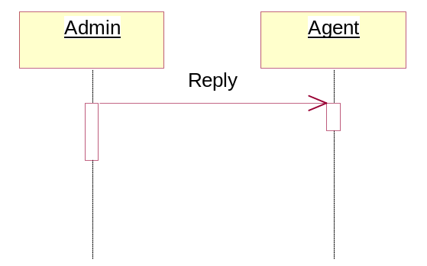

Following table lists all of possible messages existing in the UML sequence diagrams, with their graphical representations:

Simple | This is a transfer of control from on object to another.
Synchronous | If an object sends a synchronous message, it waits for an answer to that message before it proceeds with its business.
Asynchronous | If an object sends an asynchronous message, it doesn’t wait for an answer before it proceeds

Activity diagram

The activities that occur within a use case or within an object’s behavior typically occur in a sequence. This sequence is represented with activity diagrams.
The representation of the activity diagram is as follows
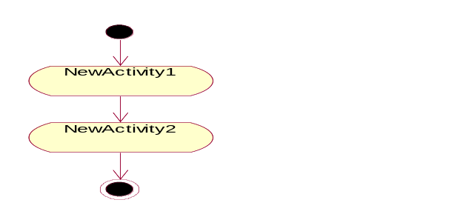

Collaboration diagram

The elements of a system works together to accomplish the system’s objectivism and a modeling language must have a way of representing this. The UML collaboration diagram is designed for this purpose.

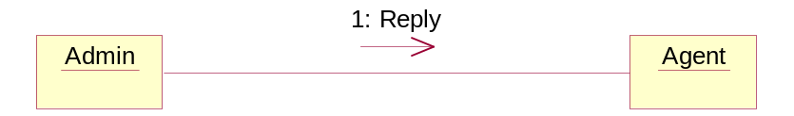

Component diagram

Today in software engineering we have team-based development efforts, where everyone has to work on different component. That’s important to have a component diagram in modeling process of the system. The representation of the component diagram is as follows

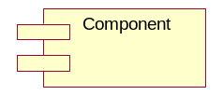

Deployment diagram

The UML deployment diagram show the physical architecture of a computer-based system. It can depict the computers and devices, show their connections with one another, and show the software that sits on each machine.

The common mechanisms in the UML

Usually in the human languages the vocabulary extends itself as time passes, therefore dictionaries are printed evgery year. Similarly in UML, when a system is designed, not all connects and terms can be expressed through the language. Therefore there are mechanisms provided by the UML to cover the details in the form of comments and constraints, to better understand the system. Bnotes capture the comments and constraints, stereotypes, tagged values and constraints are mechanisms which add new building blocks, new properties and semantics.

There are four common mechanisms that are used in UML.

Specification: These provide a semantic backplane that contains all the parts of all modes of a system.

Adornments: These are the additional details of a class whether it is an abstr4act class, or to show its visibility of the attributes and operations.

Command divisions: these are the divisions between class and its objects and between interfaces and implementation.

Extensibility mechanism: The UML can be extended in controlled ways

The extensibility mechanisms are:

- Stereotypes
- Tagged values
- Constraints

Stereotypes:

The stereotypes allow the creation of new types of building blocks similar to the existing blocks but may be specific to the current problem. Stereotyped nodes can be used to make thing appear as primitive’s building blocks, but with their own special properties, semantics and notations or icon.

Tagged Values:

The tagged value extends the properties of a UML building block, allowing you to create new information in that element’s. Specification. For example, if you are working on a shrink-wrapped product that undergoes many releases over time, you often want to track the version and author of certain critical abstractions. Version and author are not primitive UML concepts. They can be added to any building block, such as class, by introducing new tagged values to that building block.

Constraints:

A constraint extends the semantics of a UML building block, allowing you to add new rules or modify existing ones. For example, you might want to constrain the Events Quest class so that all additions are done in order.

Generally, these three extensibility mechanism allow you to shape and grow the UML to your project’s needs. These mechanisms also let the UML adapt to new software technology, such as the likely emergence of more powerful distributed existing ones, and even change their semantics.
Naturally tits important that you do so in controlled ways so that through these extensions, you remain true to the UML’

CYCLE - 1

1. ONLINE AUCTION

Overview: -

The online auction system is a design about a website where sellers collect and prepare a list of items they want to sell and place it on the website for visualizing. To accomplish this purpose the user has to access the site.

Incase it’s a new user he has to register purchaser’s login and select items they want to buy and keep bidding for it. Interacting with the purchasers and sellers in the chat room does this. The purchaser making the highest bid for an item before the close of the auction is declared as the owner of the item. If the auctioneer or the purchaser doesn’t want to bid for the product then there is fixed cutoff price mentioned for every product. He can pay that amount directly and own the product. The purchaser gets a confirmation of his purchase as an acknowledgement from the website. After the transaction by going back to the main menu where he can view other items.

As per case study, the following analysis diagrams will be created.

1. Usecases for the system.
2. Class diagram for initially identified classes.
3. Activity diagram to show flow each use case.
4. Sequence and collaboration diagrams.
5. State chart diagrams shows states before and after each action.

Conceptualization:-
Assumptions:-

- The users are allowed to register and given user id’s to have identification.
- The users are allowed to bid for any price according to their own wish provided it’s more than the minimum price for auction.
- The fixed cutoff price is decided and conformed for every product.
- The auctioneer requesting the product for the cutoff price is given priority.
- The auctioneer bidding the maximum price is given the product.

Inputs :-

- The login details of auctioneer.
- List of the available products on the site.
- Details such as specifications and the price of each product.
- Biddings price of the auctioneer.

Outputs:-

- The cutoff price of each product.
- Updated status of the bid price.
- Status of each product if it is bid or sold or for sale.
- Acknowledgement to whom the product is sold.

Key Items:-

- Get details and bid the product.
- Deliver the product.
- Pay the price and layout.

An auction simulation:-

- Bid for the product.
- Log on to the site.
- Fix or bid for the price.
- Function points.

  - Bidder request product details.
  - Pay final price and bid the product.
  - Loop.
  - Check any product details.
  - Check for cutoff price.

Requirement analysis:-

Textual analysis:-

This covers the requirement and diagrams of the project. The complete auction to bid the product.

Actors: - These are who involved in the interaction of the whole process.

- Customer: - He will log into the system and see the product, which is ready for auction. He searches for the products and bid for the products and finally he pay the money of the given bid price.

- Auctioneer: - He will visit the site and send the details of products to bidder. He will always update the bidding price. He will sell the products. He will get the price paid.

- Bank agent: - He will check the details of the credit card.

Use cases: - The steps involved in the whole process are indicated as use cases.

- Login
- Search for product
- Request for send details
- Bid the product
- Buy/sell the product
- Pay the price
- Deliver the product

Login:-

The auctioneer has to login the site and update details of the product. The customer login into the system and check the details, price of the product.

Search for the product: -

The customer will search for the product and bid the price. After bidding he will pay the money.

Request or send the details: -

The bidder will send the details of the product and the bidder also sends the details to the customer.

Bid the product: -

The customer will bid for the product and pay the money to the auctioneer.

Buy/sell the product: -

The bidder will sell the product and customer will buy the product.

Pay the price: -

The customer as to pay the price and get the product. Check validity of credit card by the bank agent.

Deliver the product: -

After the customer has paid the money the auctioneer has to deliver the product.

Uecase Diagram:

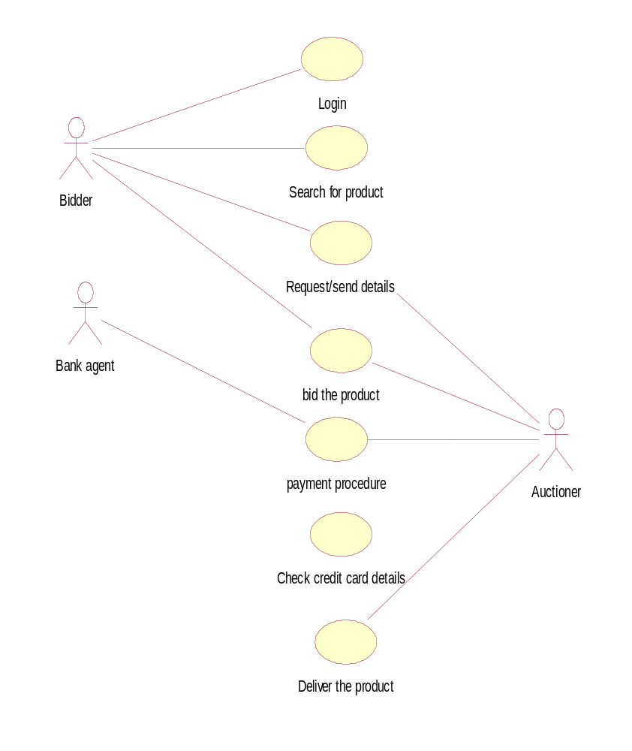

Activity Diagram:-

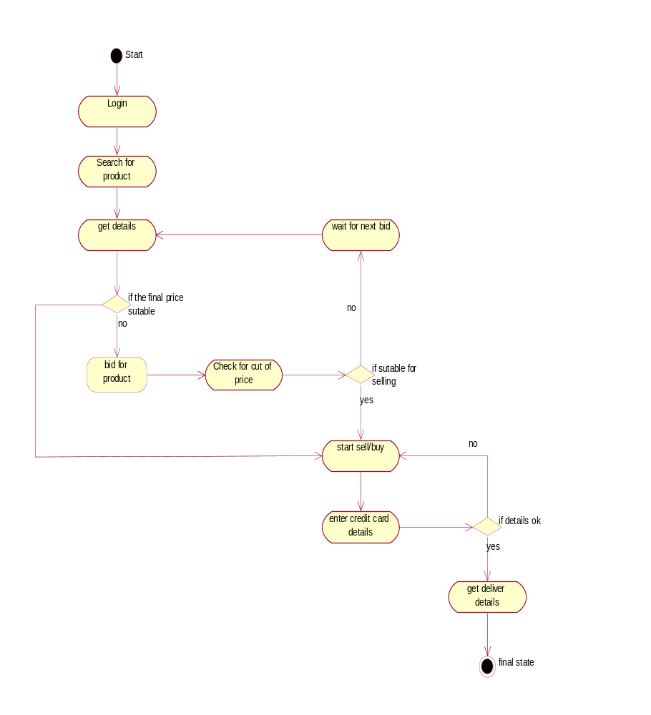

Sequence Diagram:-

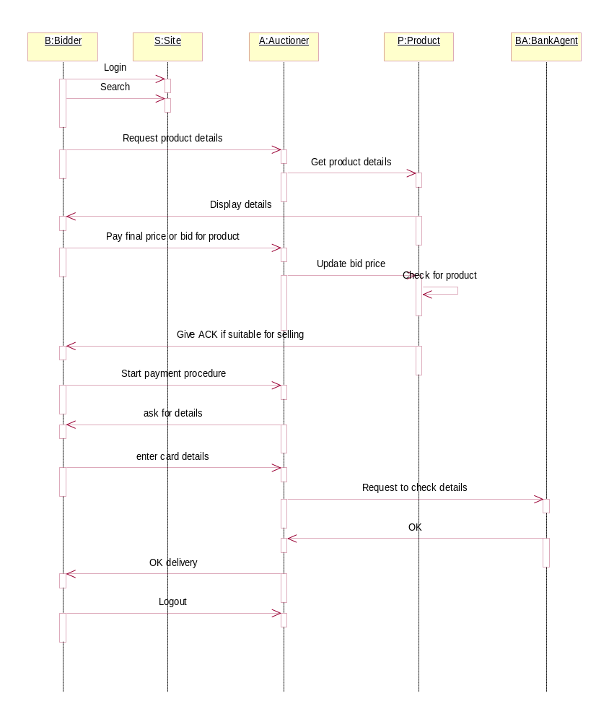

Collaboration Diagram:-

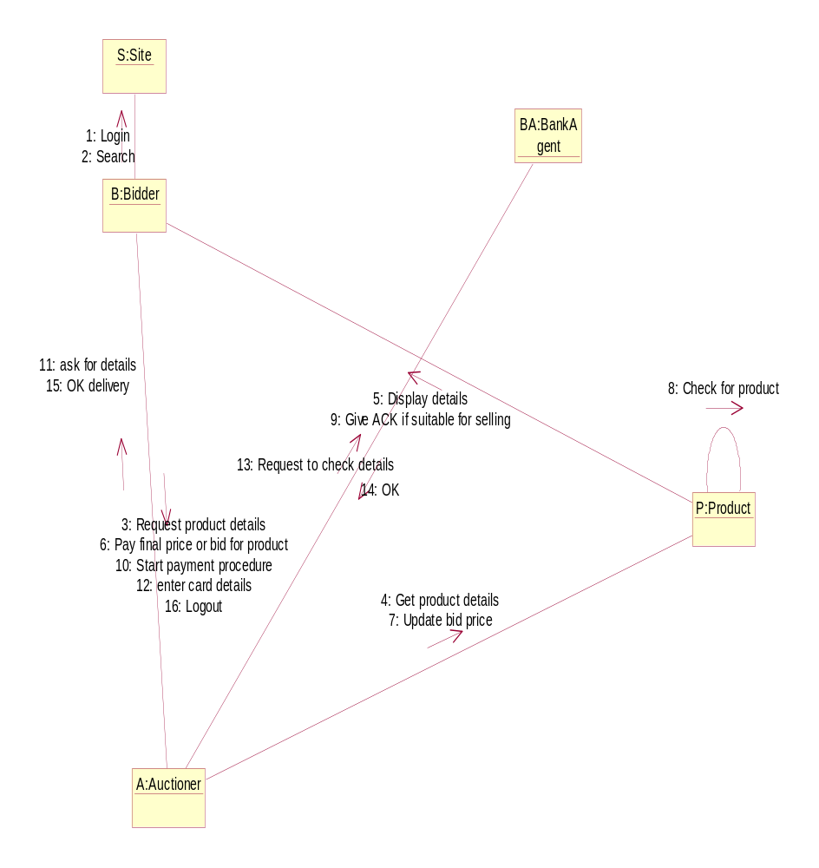

Class Diagram:-

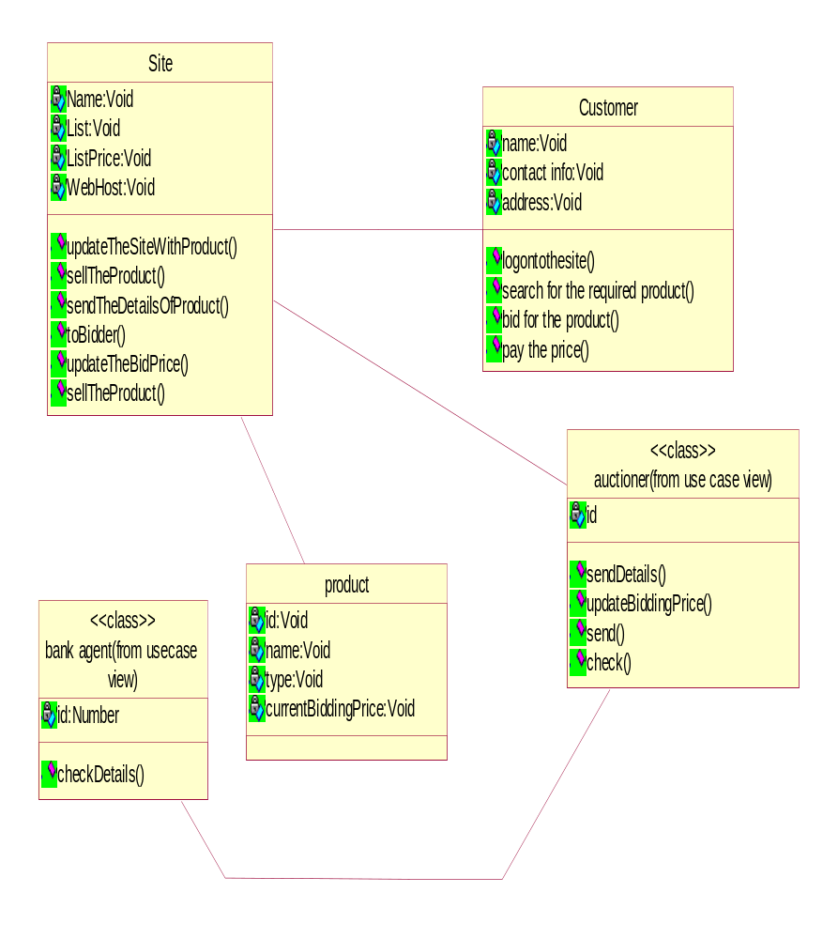

Component Diagram:-

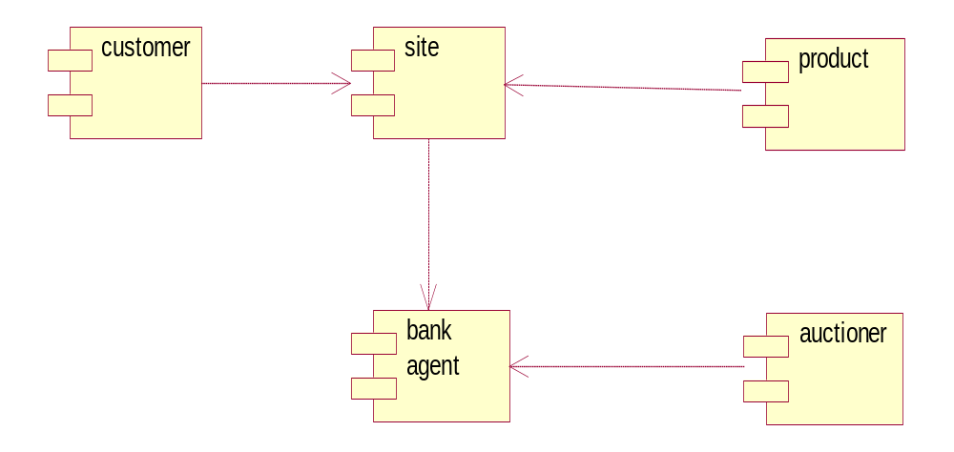

Deployment Diagram:-

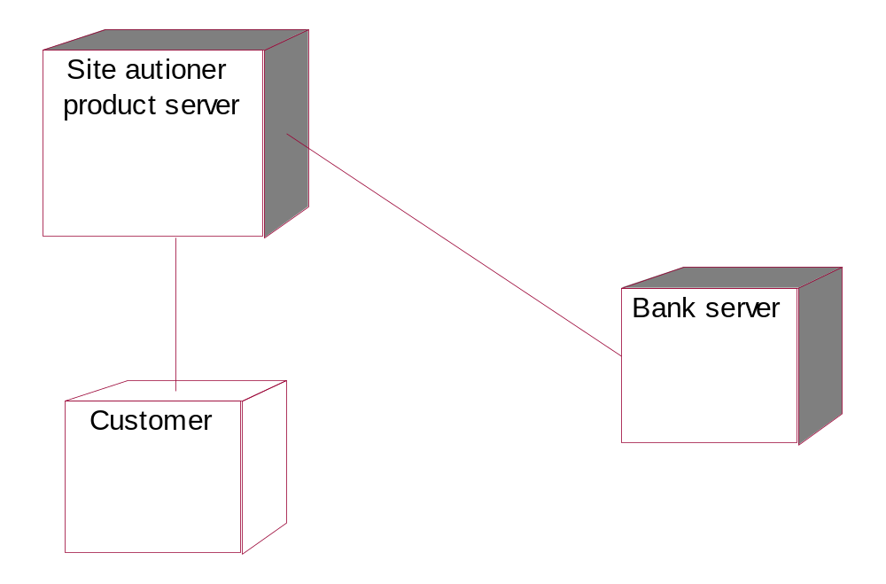

CYCLE - 2

2. ONLINE RAILWAY RESERVATION SYSTEM

OVERVIEW:

This Project is about online railway reservation system. The functionalities of the system include the following:
1. Using the web facility to enter into system.
2. Going for reservation or cancellation options those includes payment through credit card system and getting the ticket / cancellation of the same.

Actors:

The actors involved here are:

- Passenger: Who use all the functionalities provided.
- System Administrator: Maintains the information related to train details and monitors the total railway reservation system.
Use cases :

- Check the details:
This use case provides the facility of checking the total details of the railway reservation system.

- Reservation :
This use case provides the facility of reservation of the ticket through online.

- Cancellation:
This use case providing the facility of cancellation of the ticket through online.

- Third party:
This use case provides the facility of verifies the credit card details of the passenger.

Usecase Diagram:

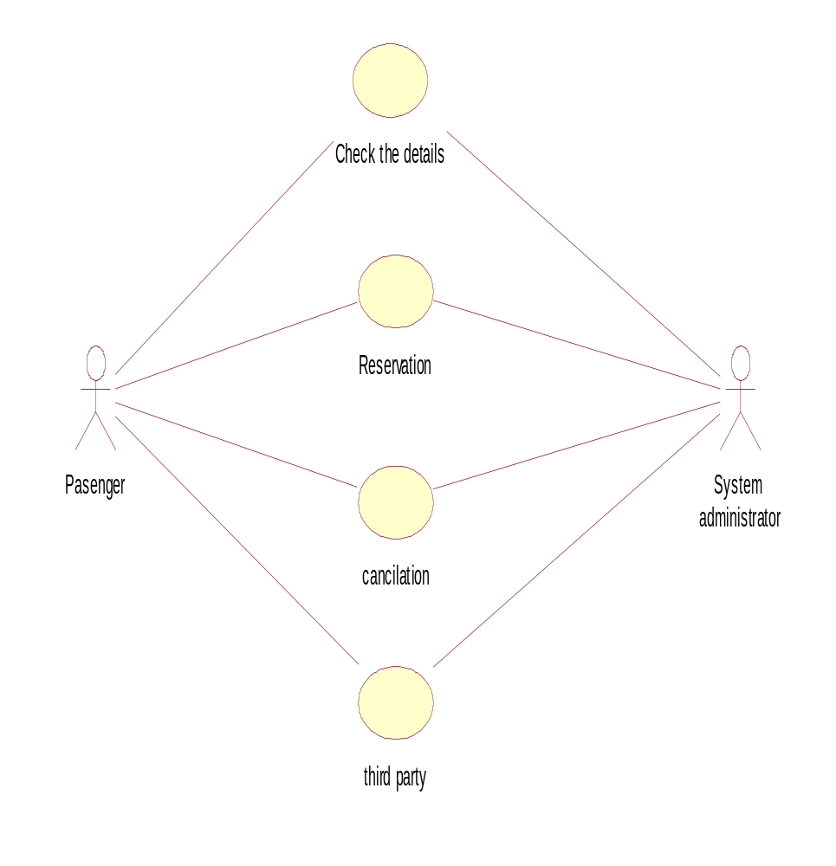

Activity Diagram:

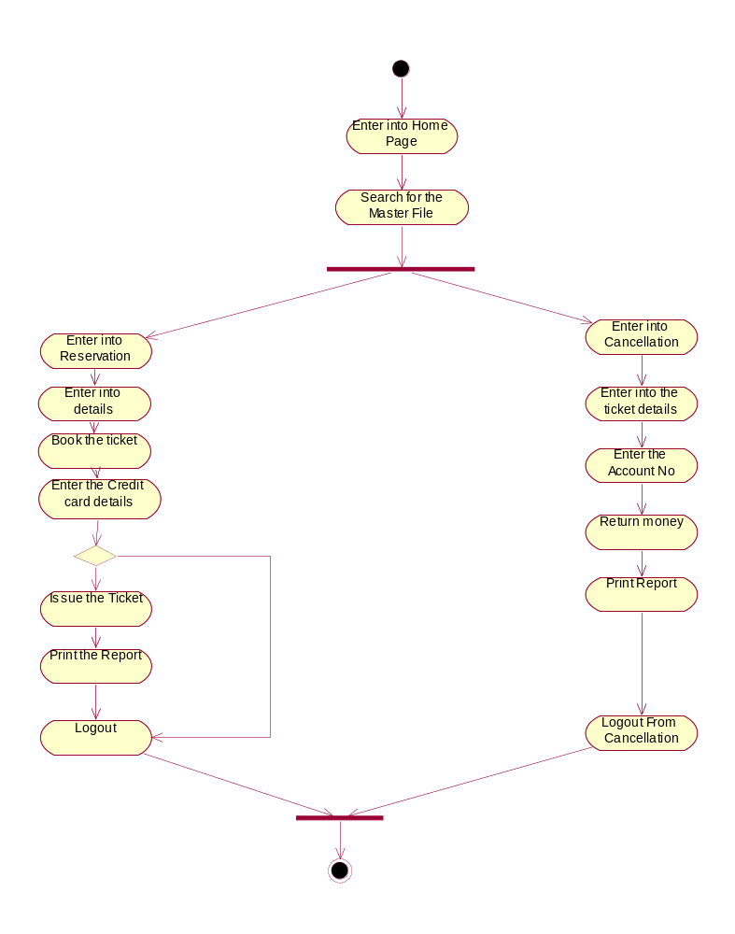

Sequence Diagram for Reservation:

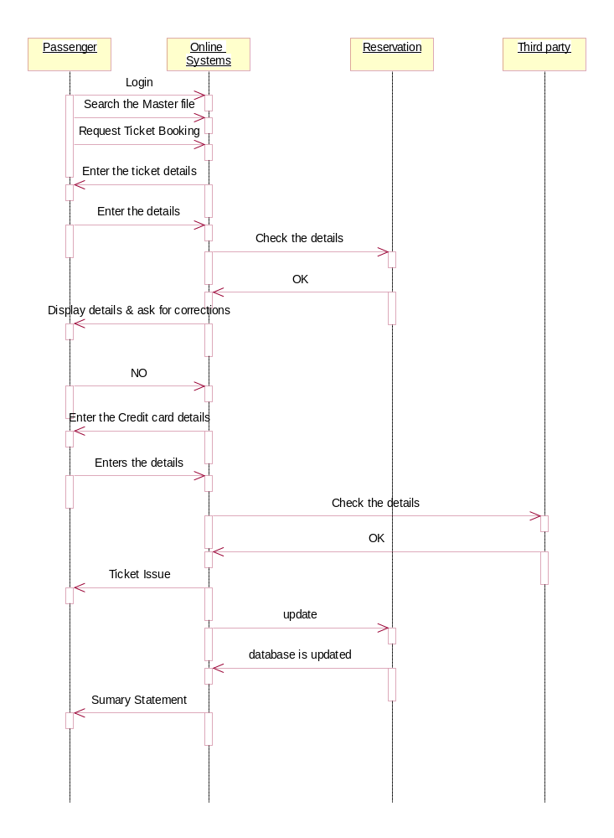

Sequence Diagram for Cancellation:

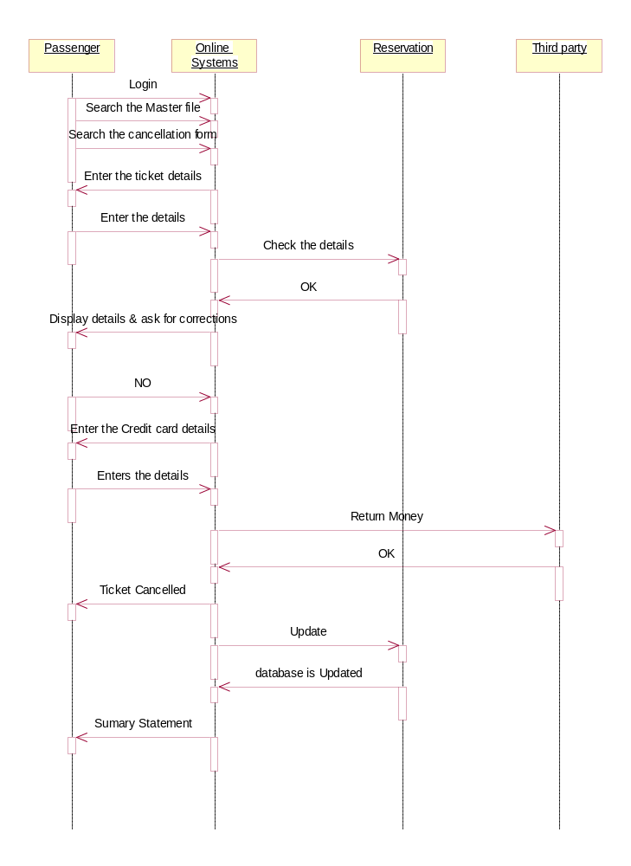

Collaboration Diagram for Reservation:

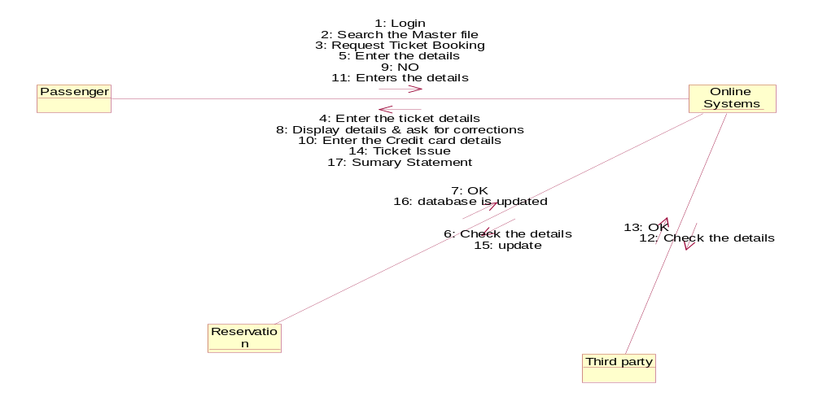

Collaboration Diagram for Cancellation:

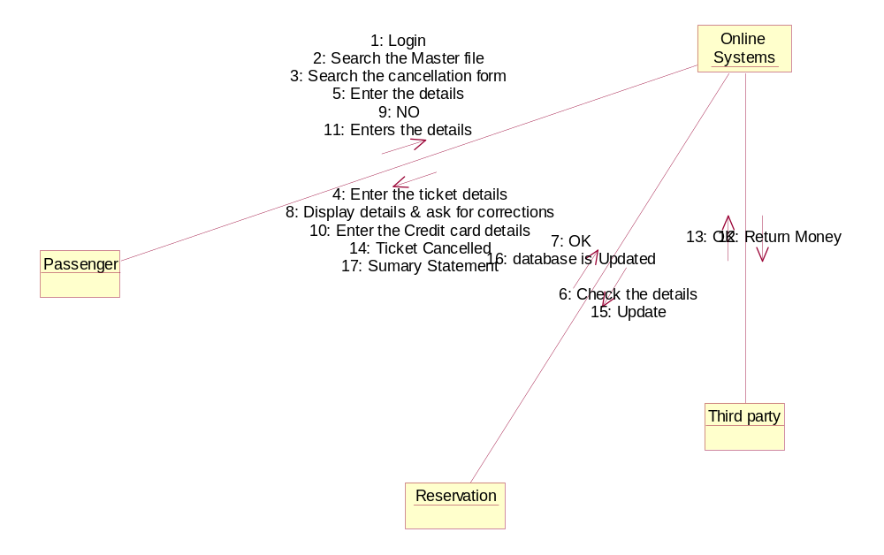

Class Diagram :

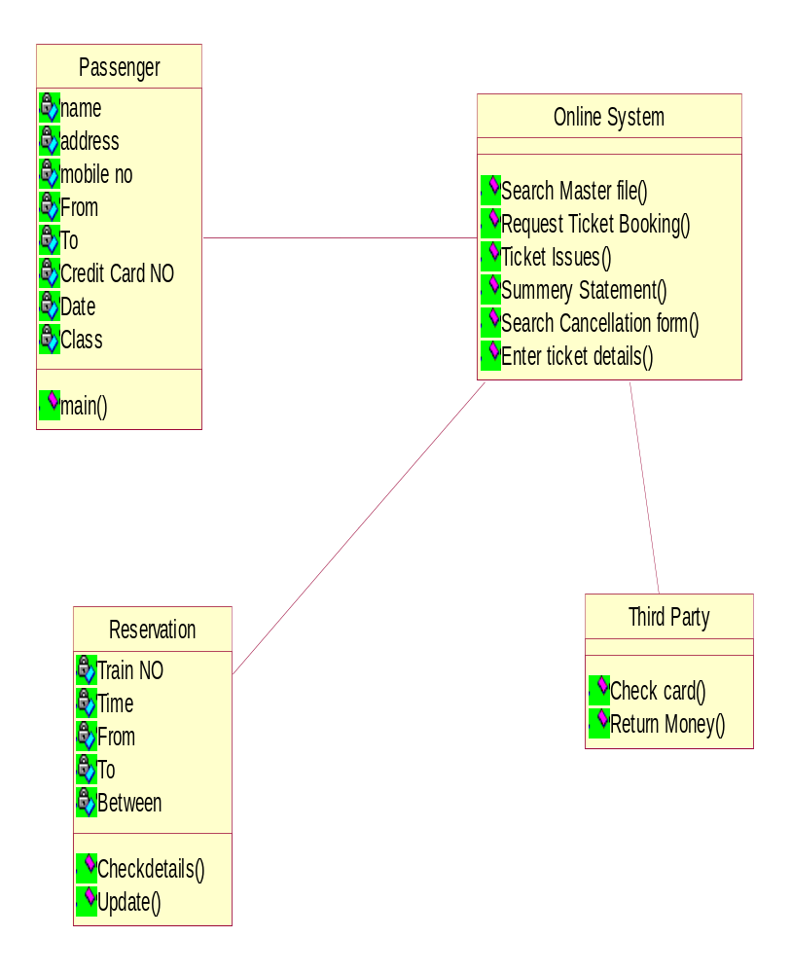

Component Diagram:

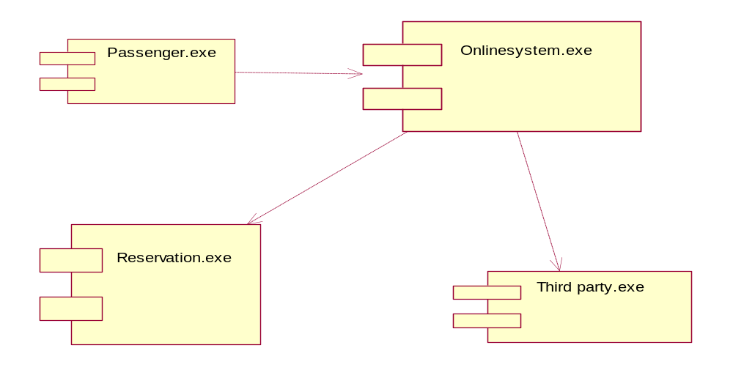

Deployment Diagram:

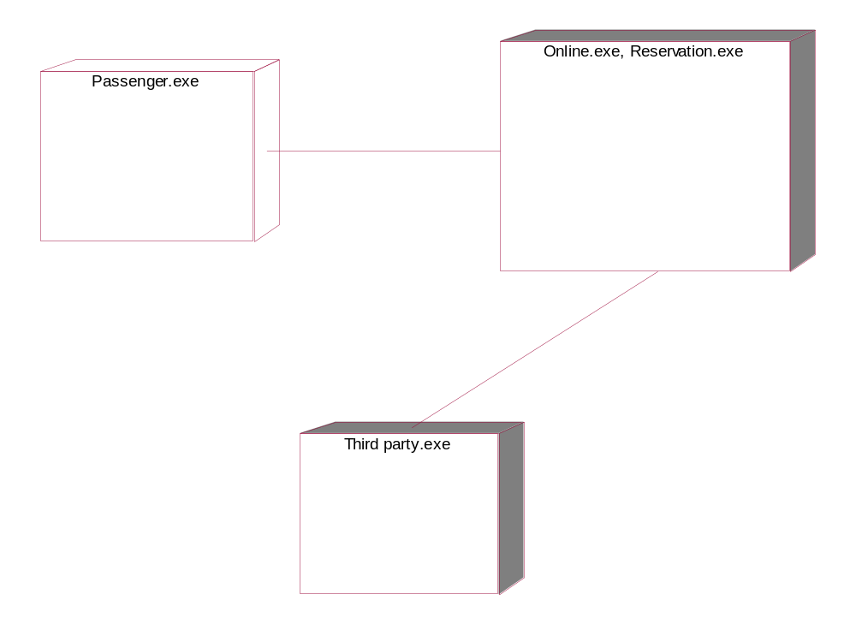

CYCLE - 3

3. ONLINE BOOK SHOPPING

There is a book shop which provides the online shopping facility to the customer. At the beginning itself customer login in to the system view the catalog and select book. Selected books along with credit card details. Then the system verifies the credit card details with help of third party. If details are valid then shop keeper processes the bill and delivers the ordered books to the customer. It is the responsibility of the shop keeper to maintain sock in the store. And also deliver the ordered books to the customer

Actors:
1. Customer
2. Shopkeeper
3. Bank agent

Roles:

CUSTOMER : View catalog, select book, order book
SHOPKEEPER : Process bill, maintain stock and deliver the books
BANK AGENT : Verify credit card details

Use Cases:

View catalog: Customer view the list of the books available in the book stop
- Select book: Customer selects the book which is added to the cart
- Order book: Select books are order by customer
- Process bill: By referring the customer order shopkeeper process the bill by verifying Credit card details.
- Add/update/delete book: All activities are done by shopkeeper
- Prepare sales report: Shop keeper generate total sales report

Usecase Diagram:

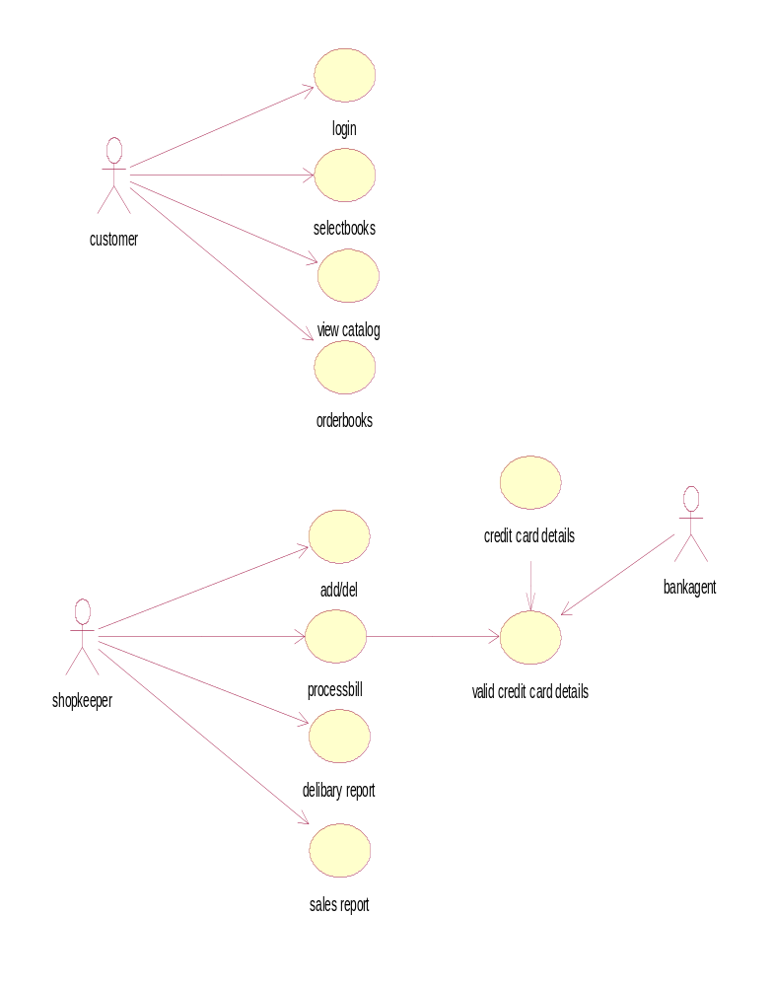

Activity Diagram:

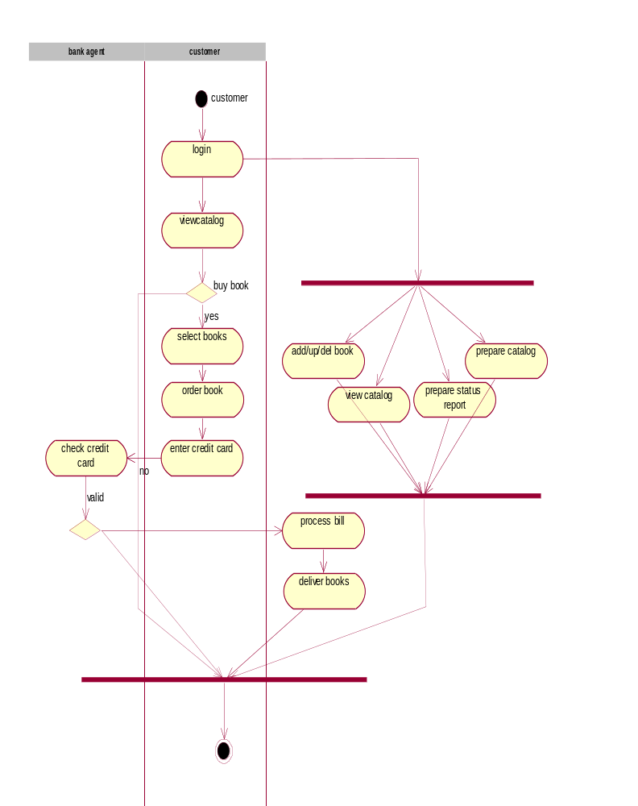

Sequence Diagram:

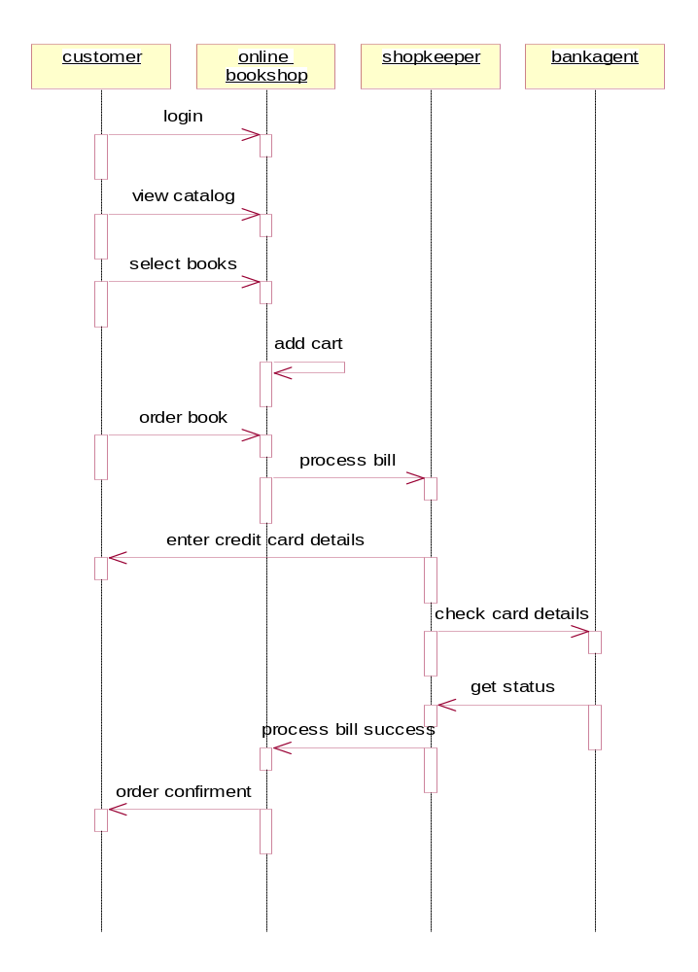

Collaboration Diagram:

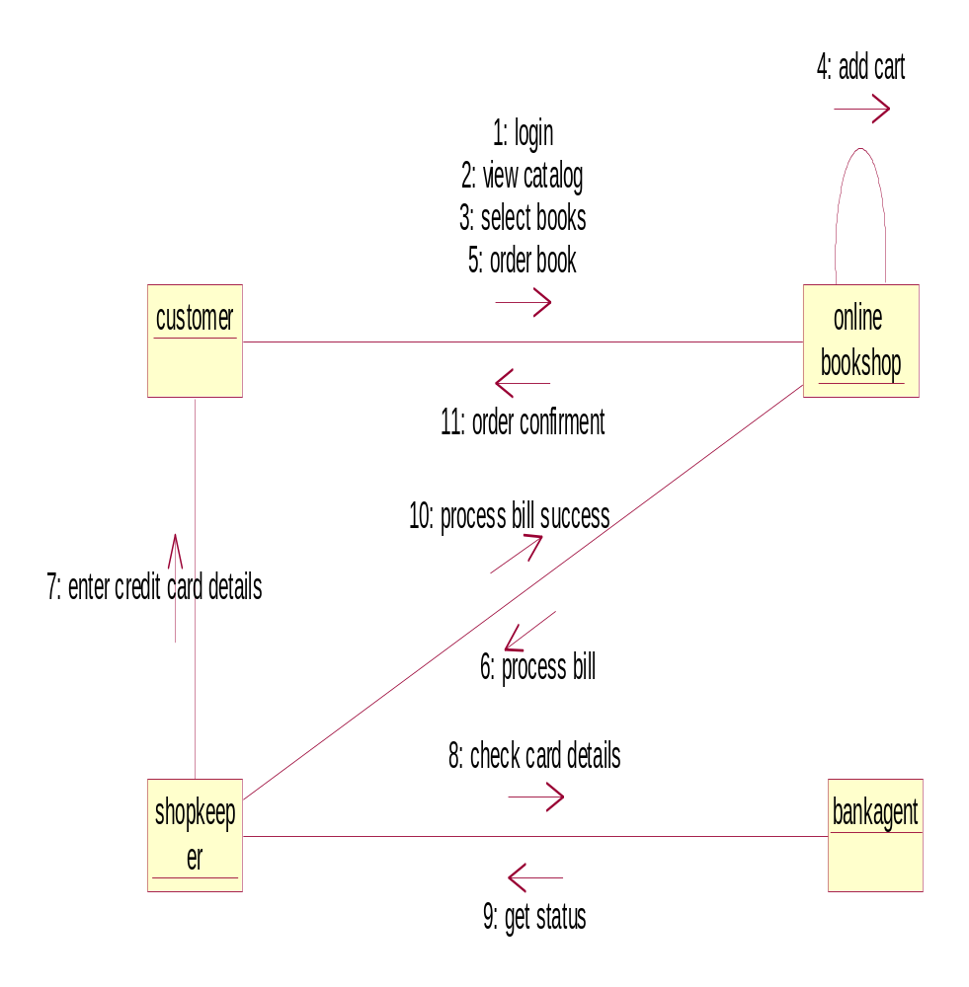

Class Diagram:

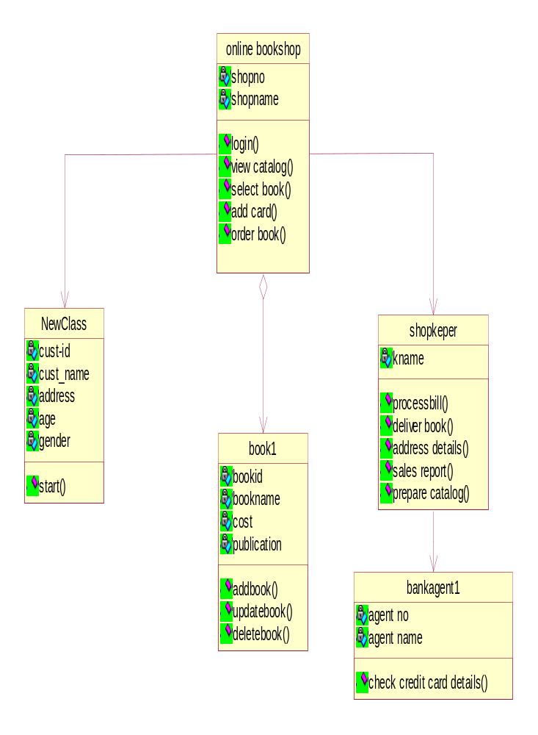

Component Diagram:

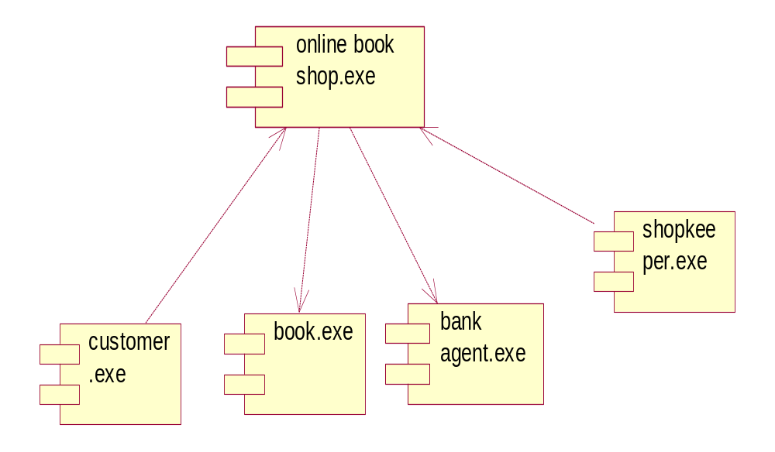

Deployment Diagram:

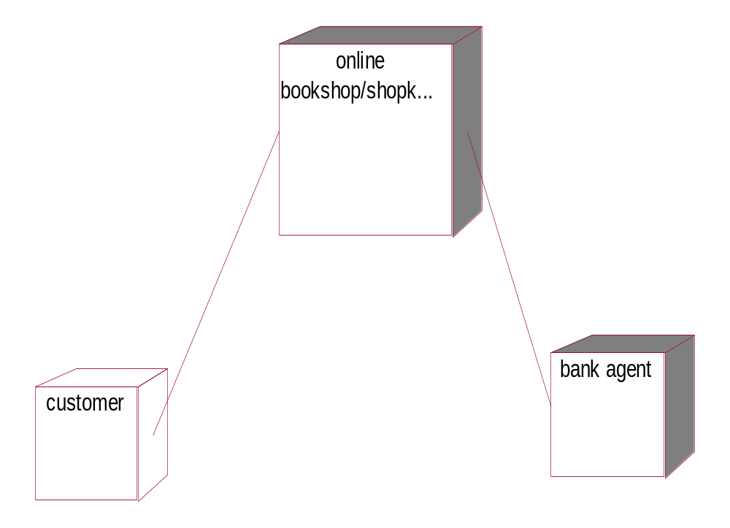

CYCLE - 4

4. Library Management System

Overview:

A college library is filled with books, periodicals, journals, magazines. It also has audio & video cassettes as well as CD ROM’s. The library leads to bonafied members.

Membership of the college library is restricted to staff & student of the college. They are issued with membership cards which contain a unique id. The library purchasing & adding items to it inventory in database.

Users of the librarian & the barrowers, the library is in need of a web application which automates the function of the library.

It must have the capability to allow members to browse, search, barrow systems, and also support systems to manage inventory & the members.

The system must contain a DB comprising of title’s & items in its inventory. Since librarian have multiple copies of popular books & the magazines, the title name of book & the author must be stored separately & the physical member of this title stored separately as an item.

Actors:-

Librarian: - The librarian will have complete access to the system & permits the students & staff with a unique id.

Student: - Enter into the library management system with valid register id, search for books & selects the book.

Staff: - Enter into the library management system with valid register id, search for books & selects the book.

Use case:-

Login: - Permitted to login with a unique register id.

Add/Del/Upd /books: - Add new books to the DB. Delete the issuing books from the list of available & updates the DB.

Add/Del/Upd/students info: - Add students list to the DB with their register id & performs deletion & updates the DB.

Check-in: - Librarian should perform the check-in operation whether the student information entered is valid or not. If valid provide the transaction as for the student requirement.
Check-out: - Barrowers should be allowed to check-out before issuing the required books.

UseCase View:-

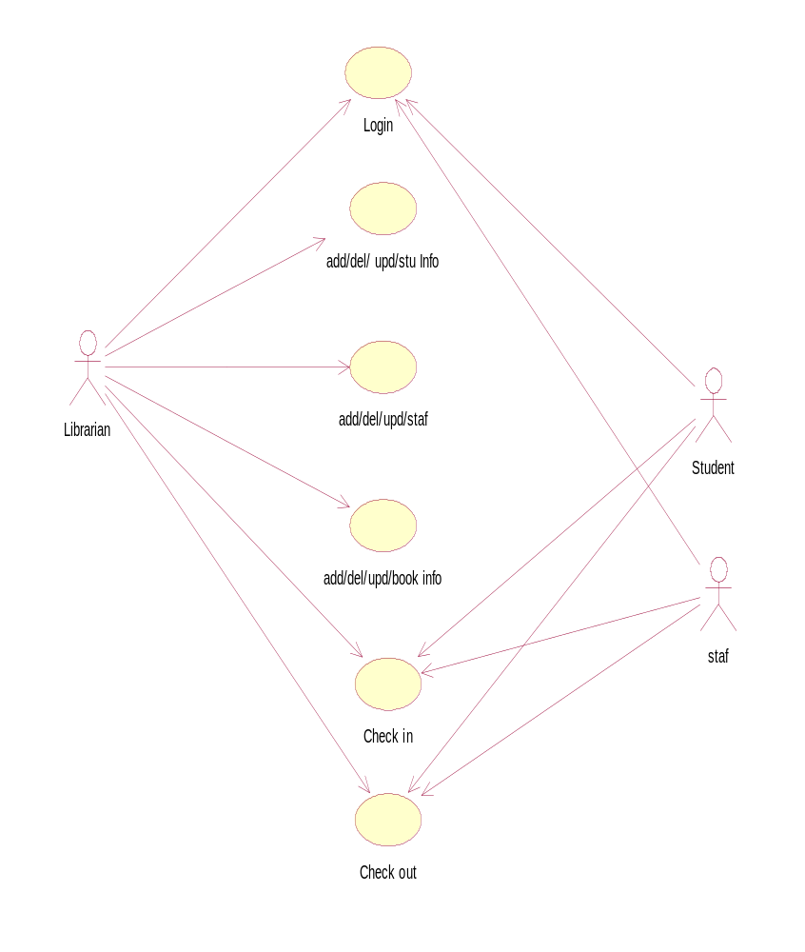

Activity Diagram:-

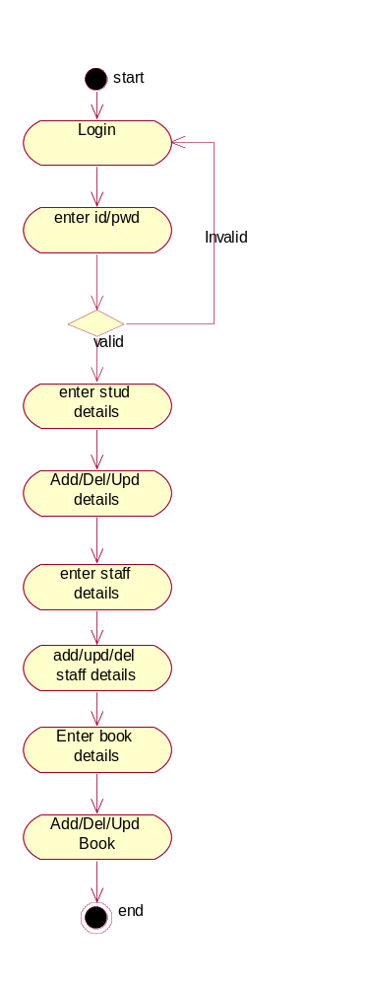

Sequence Diagram:-

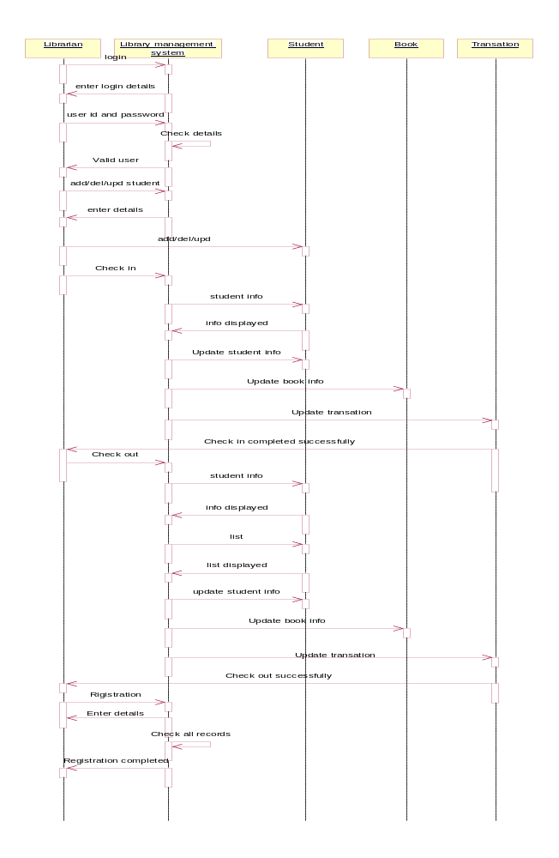

Collaboration:-

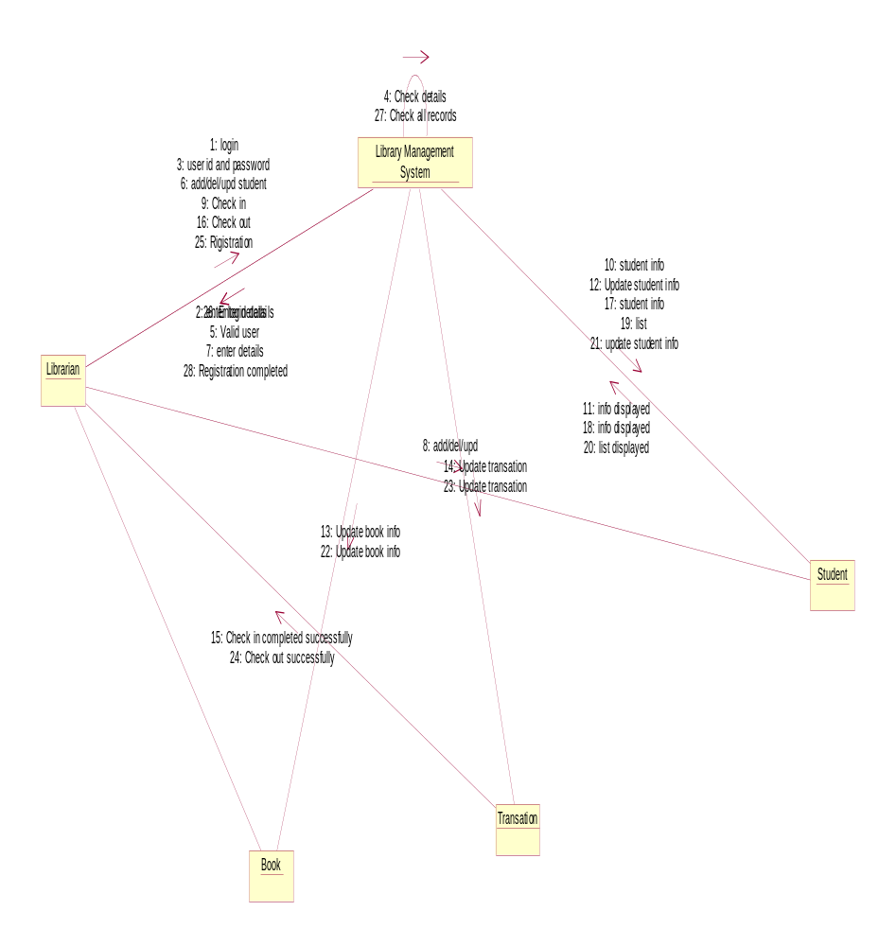

Class Diagram:-

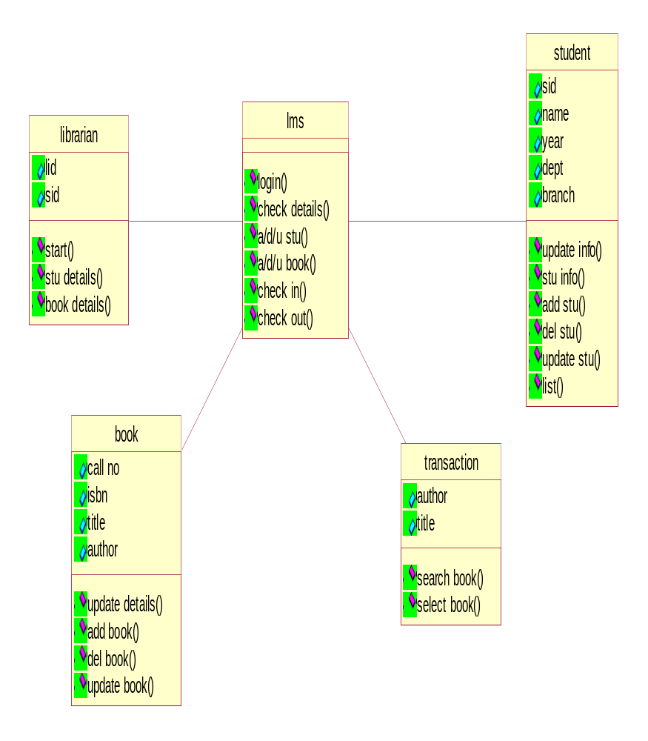

Component Diagram:-

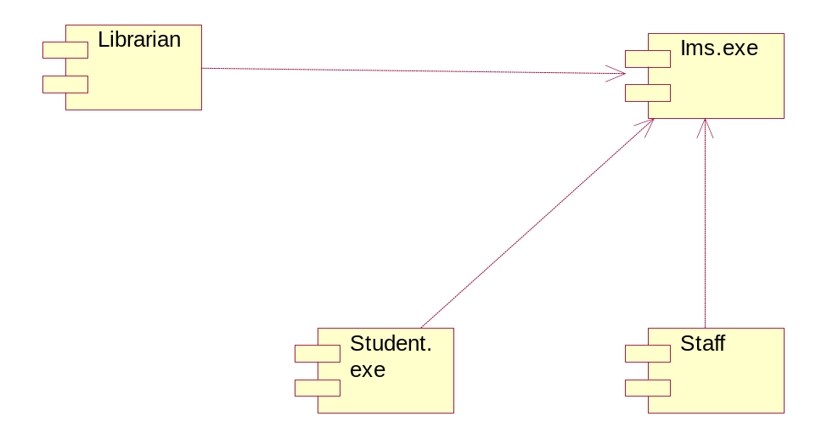

Deployment Diagram:-

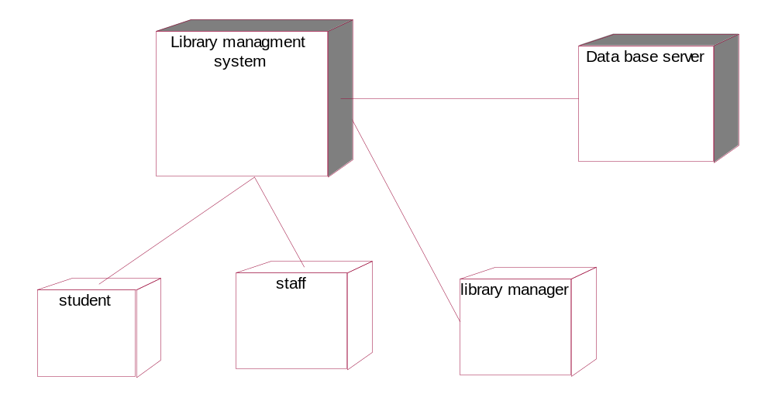

CYCLE - 5

5. Automated Teller Machine

Over View:

This project is about using ATM teller machine. The

Functionalities of the system include the following
- Checking the account.
- Deposit the money to account.
- Withdraw the money using ATM card.

Use case Diagram:

Actors:

- Client: Withdraw the amount using ATM card and deposit the money to amount.

- ATM Machine: Takes ATM card and checks the details of client , and give the money , update account.

- Bank Client: Checks the client details

Use Cases:

- Checking Account: Deposit or withdraw amount from account.

- Saving Account: Deposit or withdraw amount from the savings account.

- Bank Transaction: All the transactions are performed using this use case.

Usecase Diagrams:

Checking Accounts Package

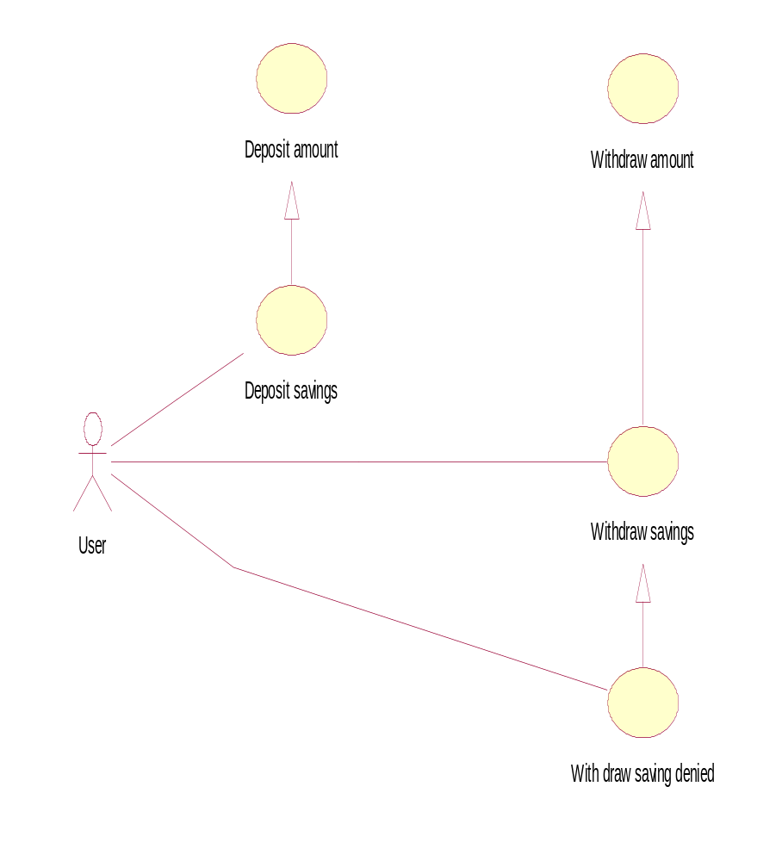

Invalid pin number

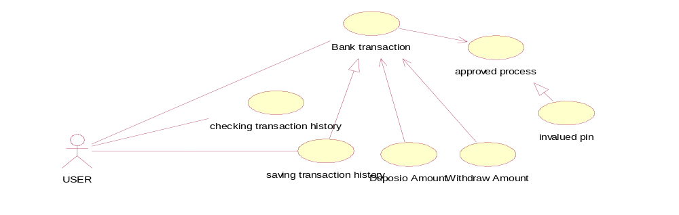

System Transaction Package:

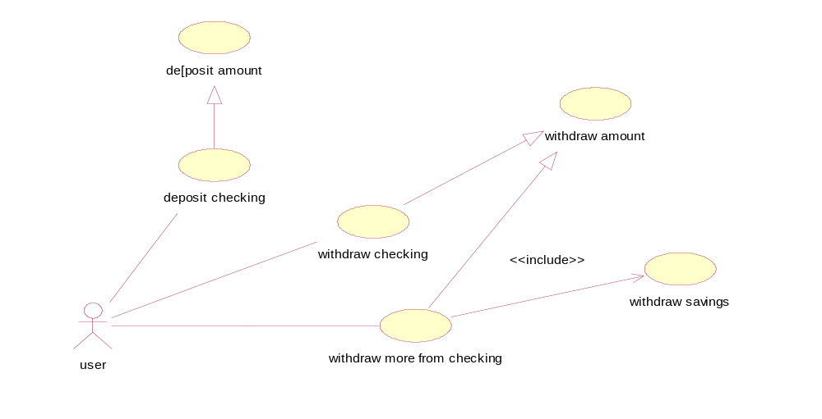

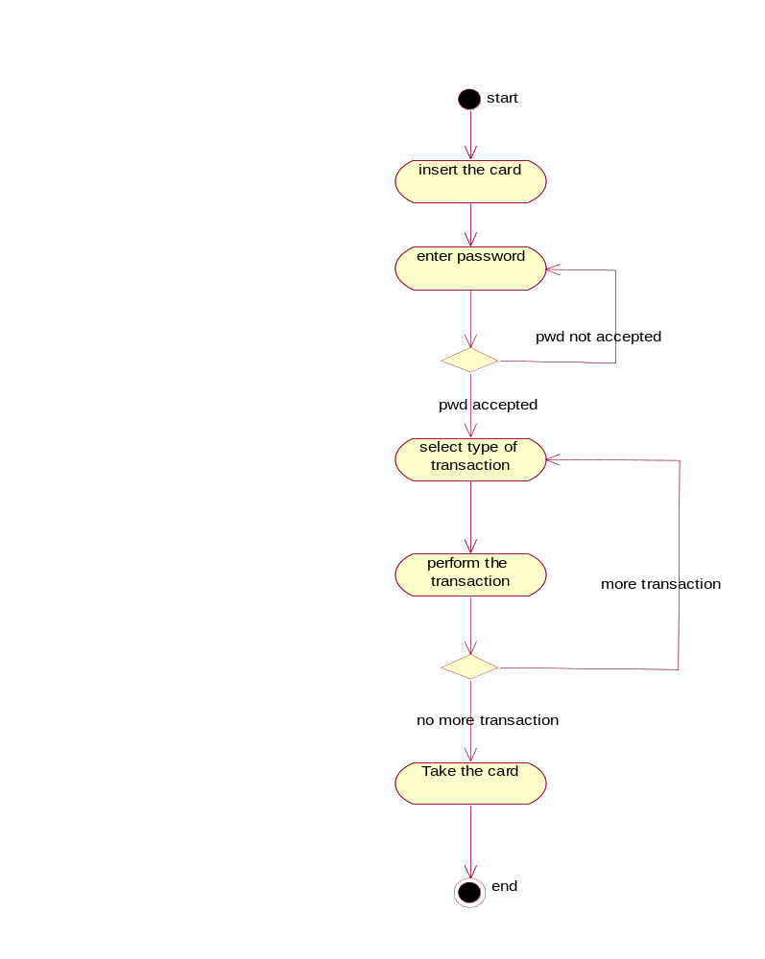
Activity Diagram:

Sequence diagrams:

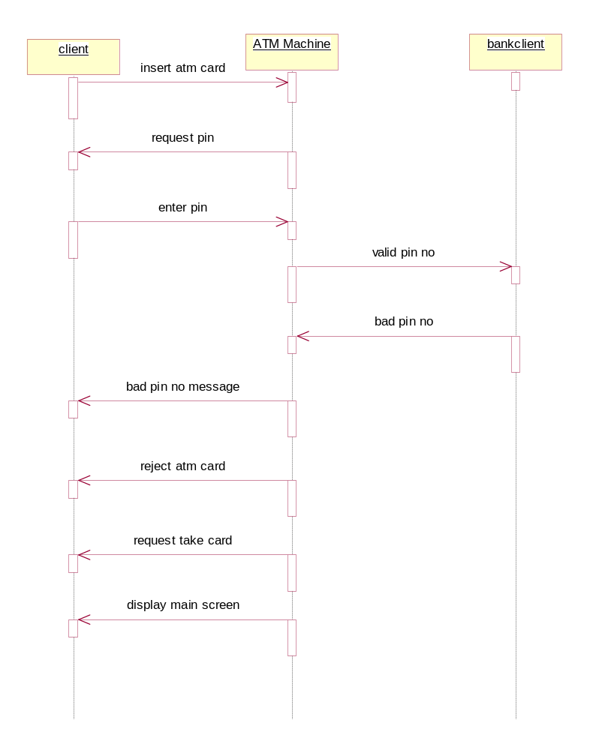

Withdraw checking use case
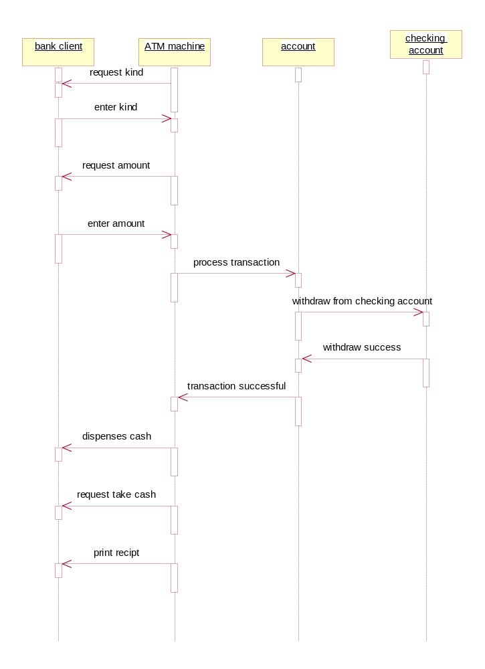

Withdraw more from checking use case

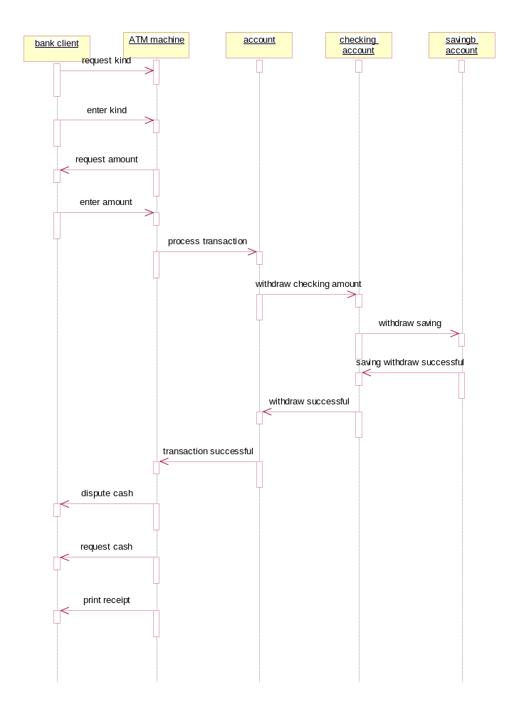

Collaboration Diagrams:

1. Invalid pin number

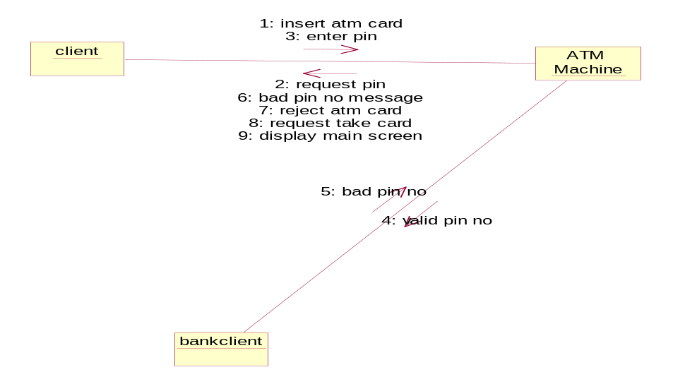

2. Withdraw checking use case

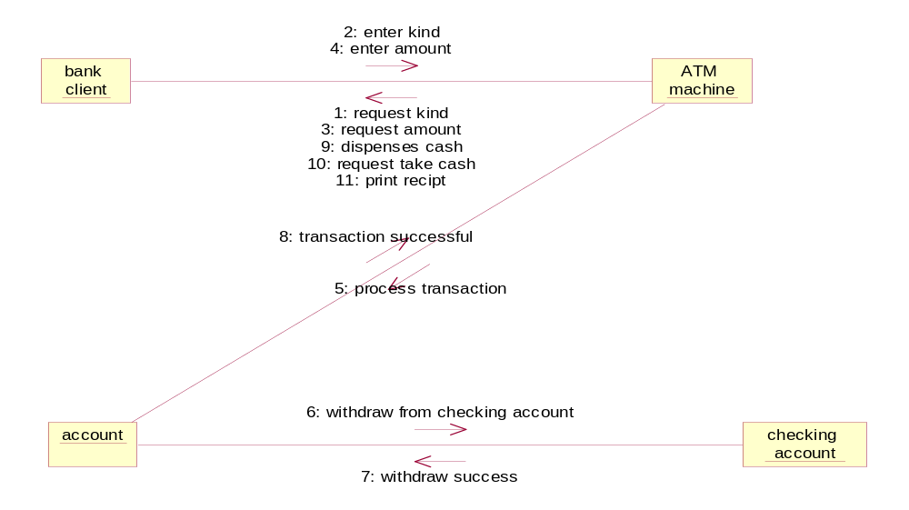

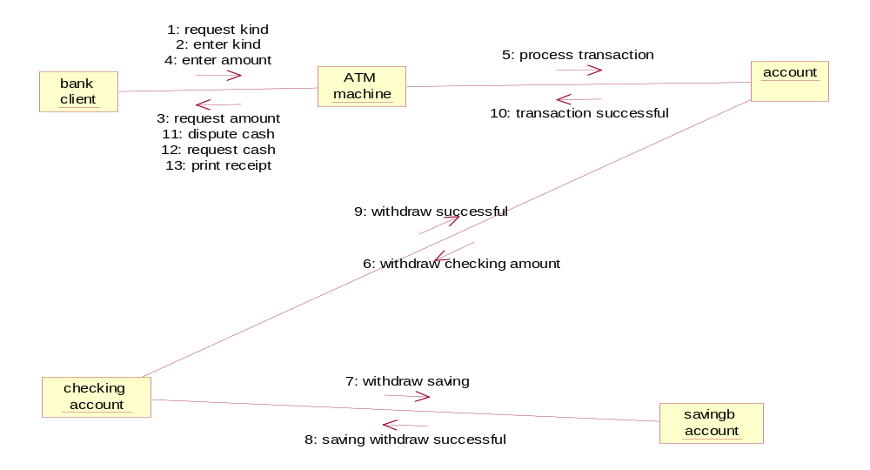

State chart diagram

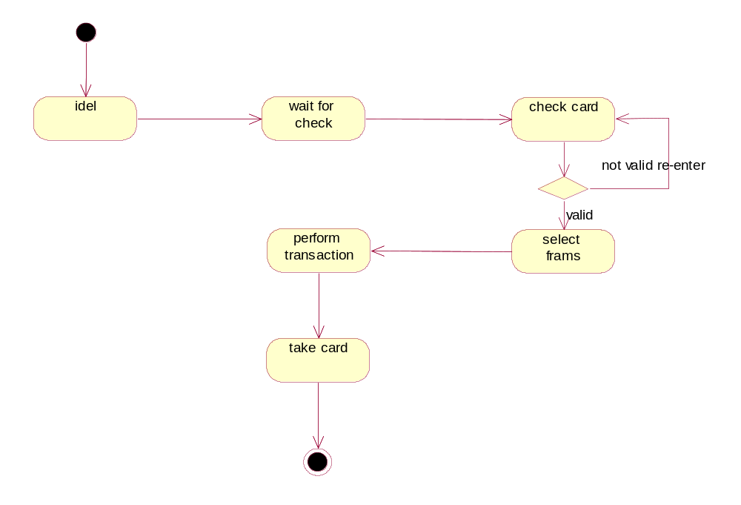

Class Diagram

